APPLECROSS SENIOR HIGH SCHOOL
3A 3B Human Biological Sciences
Endocrine Assessment

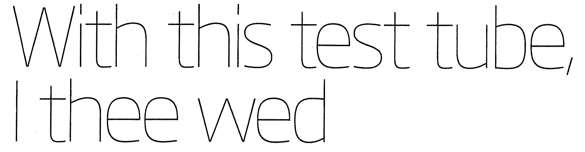

1) Name the dependent variable in the article ____________________________________ (1)

2) Name the independent variable in the article ____________________________________ (1)

3) In scientific investigations, a control group is used to identify differences as a result of manipulating variables. Was there a control group in this experiment? Explain how comparisons could be made in this case, and differences detected, if there is/isn’t a control group present.

(2)

4) The article states “oxytocin is released from the pituitary gland”. Which lobe is it released from?

______________________ (1)

5) This study has been looking at the role of oxytocin in empathy. What are three other things is oxytocin thought to play a role in?

(3)

6) What is the main hypothesis being tested?

(2)

7) Why do you think ACTH and Cortisol levels were measured? Explain.

(2)

8) Looking at the graphs, what do the “mutual friends” all have in common?

(1)

9) Do you believe this study conclusively supports the hypothesis? Why/Why not

(2)

Total: /15

